CONTROL TOWER MANUFACTURING UPDATE-Through Mobile
- Click on the MFG Control Tower Icon.
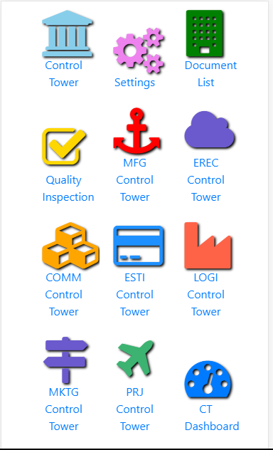
- Following Screen will appear. 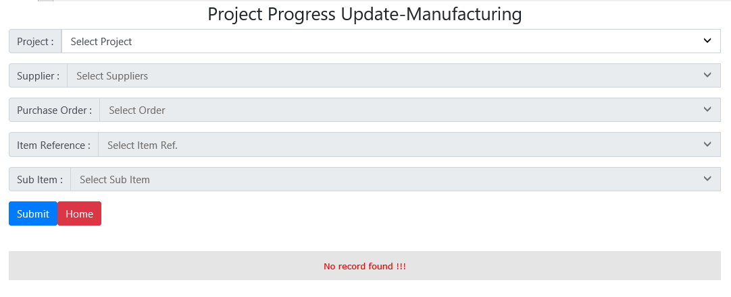
- Click on Project Dropdown List to select the Project. 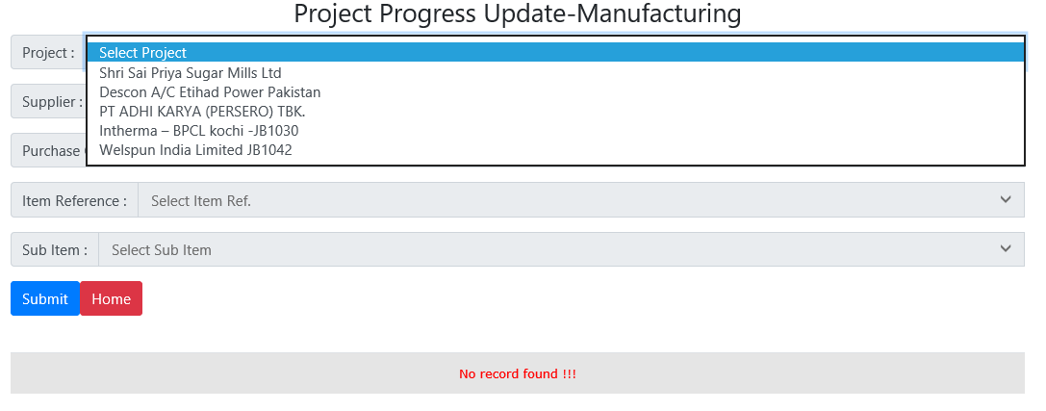
- Then in supplier dropdown list, it will show only those suppliers, to whom PO is issued in selected Project. Select the supplier. 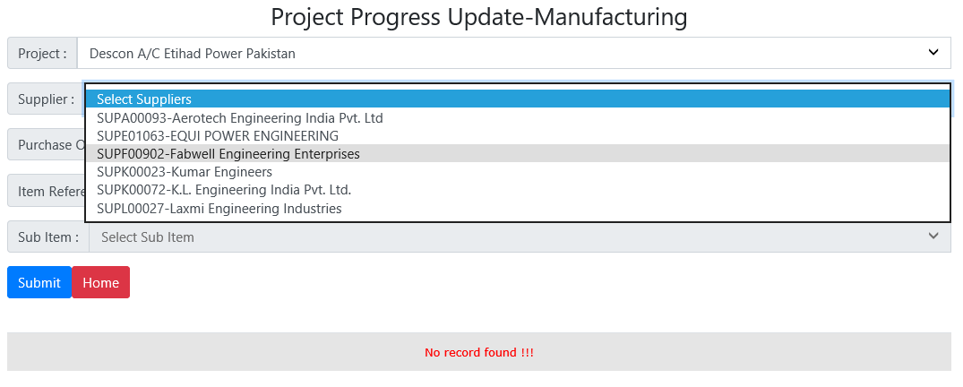
- Then in purchase order dropdown list, it will show list of PO, issued to selected supplier for selected project. 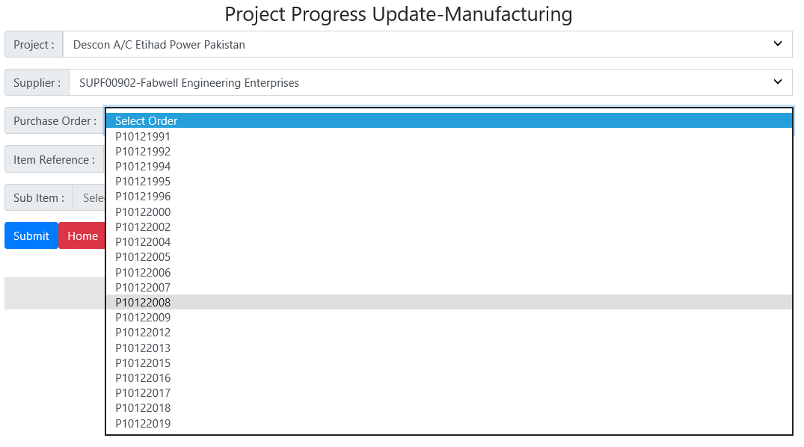
- Then in Item Reference dropdown list, It will show Items of the PO. 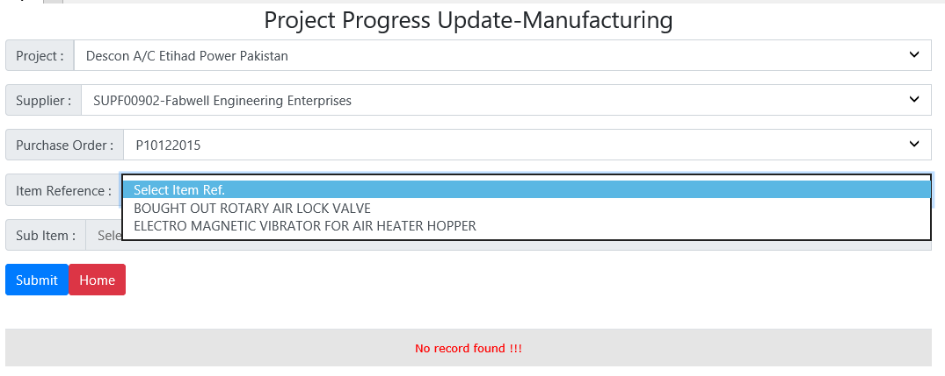
- Then in Sub. Item dropdown list, it will show the sub items. [If Item contains the sub item] 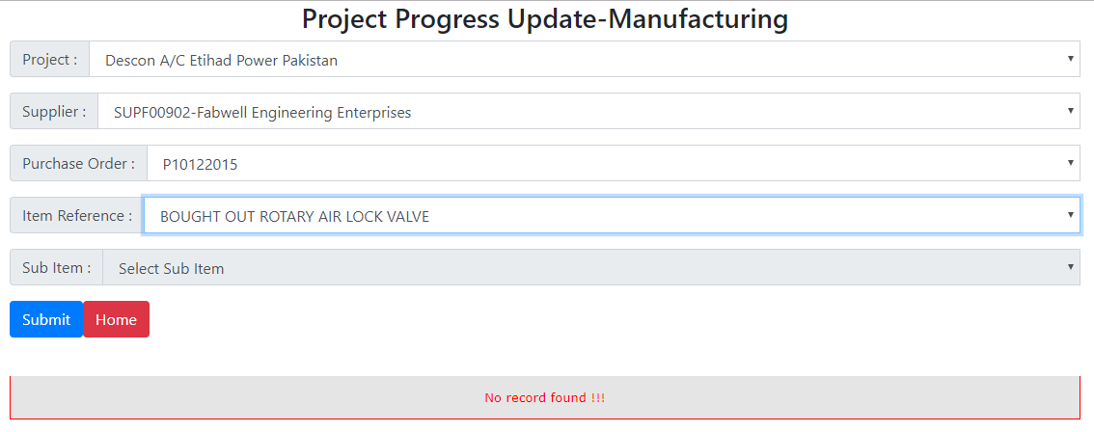
- Click on the Submit Button. It will show the list of Activities. Click on the activity description to update % Progress.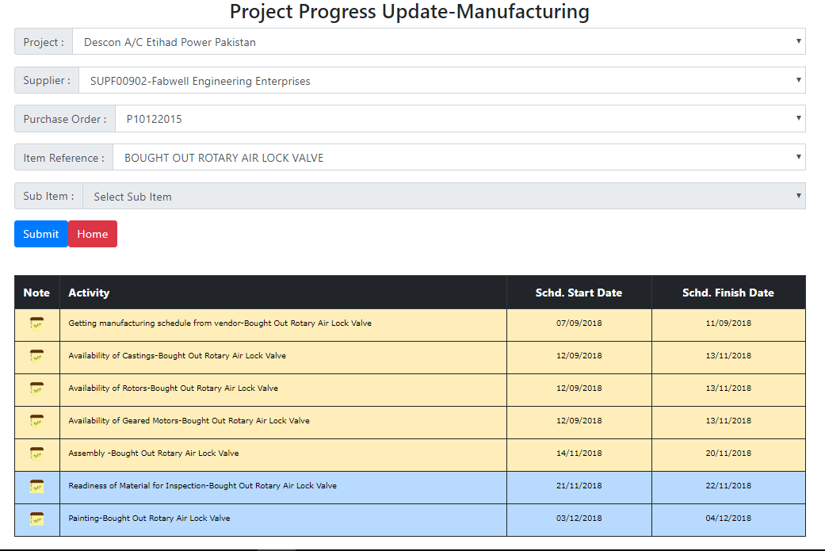
- Follwing entry screen will appear. 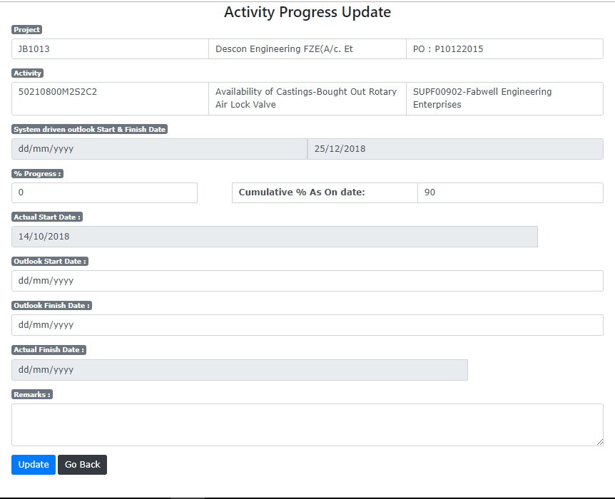
Enter % Progress here. Then click on Update button below.

